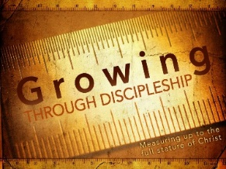
Discipleship Class 201:
Discovering My Spiritual Maturity.

Class 201 is designed to teach you about these simple habits (the Bible reading, Prayer, Tithing, Fellowship) and show you the different steps you can take to mature and grow as a Christian. This class will be held on Thursday December 8, 15 from 5:00-6:30 pm. Dinner will be served.

Wednesday Connections

A way to connect unchurched friends and family to our church family in an inviting atmosphere through the sharing of a meal and devotion.
Meal serving starts at 4:45 pm with devotion at 6 pm. Through the Advent Season, this will focus on “Roots – Advent and the Family Story of Jesus”.

Celebration Sunday

It’s time to Celebrate!
Join in Celebrating our Giving. Sunday morning December 4 with potluck meal and festivities to follow. Bring your Financial pledge and Time and Talent offerings to service or mail in prior.

Advent Season Small Group Bible Study
10:30 am on Sunday.
Nov. 27, Dec. 4, 11, 18,
The heart and mission of Emmanuel, God with us, is more profoundly understood by exploring the well-watered roots that flowered into Jesus’s life as the Word of God made flesh (John 1:14). You are invited to grow and strengthen your own roots as you learn about the roots of Jesus - his family tree and its characters, the land of Israel and its towns and terrain, and the incredible faith-story of God’s covenant people, the Jews.
3 opportunities to gather for discussion:
1. Sundays 10:30 am after worship in the Library
2. Wednesdays 6 pm in Fellowship Hall
3. Make your own small group - see Pastor for video

UNITED WOMEN IN FAITH

Are selling Rice Packs for the next two Sundays as a fundraiser for their 2023 Pledge to Missions. Freewill donations are accepted.

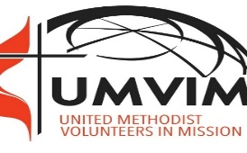
UMC of WISCONSIN’S VOLUNTEERS IN MISSION

Marion, Alabama, February 4-12, 2023 to partner with a Marion group to do home repair. More information available on the mission outreach bulletin board.
If interested contact Charlene Galston.

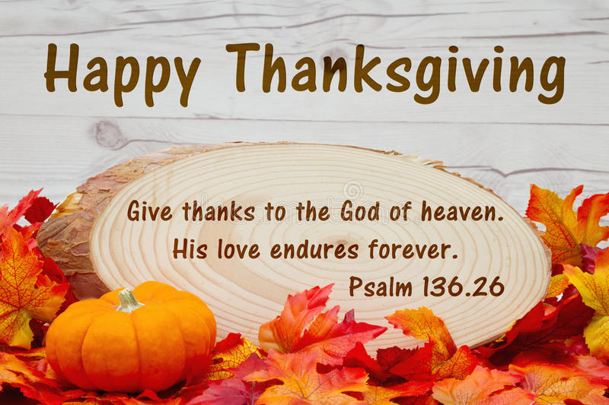

Thanksgiving Eve Joint Service

November 23, 2022
6 pm

Black River Falls UMC

100 North Fourth Street, Black River Falls, WI. 54615
Phone: 715-284-4114
www.brfumc.org & Black River Falls United Methodist Church Facebook
brfumc at YouTube

ORDER OF WORSHIP

Prelude Give Thanks Katrina McGillivray/David Shon
Welcome
Lord of bounty and blessing, we come to you this day in gratitude for all that we have been given. We are grateful for the blessings and for the opportunities to be of service to others in your Holy Name. Bless each of us here, that we may become true blessings to others. For we ask all of these in the name of Jesus. Amen

Call to Worship: Deuteronomy 8:7-11a
Moses told God’s people that “the Lord your God is bringing you into a good land, a land with flowing streams, with springs and underground waters welling up in valleys and hills, a land of wheat and barley, of vines and fig trees and pomegranates, a land of olive trees and honey, a land where you may eat bread without scarcity, where you will lack nothing, a land whose stones are iron and from whose hills you may mine copper. You shall eat your fill and bless the Lord your God for the good land that he has given you.” Then he gave them a warning: “Take care that you do not forget the Lord your God.” Sisters and Brothers in Christ, we come together to worship our God, who is present with us wherever we are, and to remember how the Lord has blessed us.
Opening Prayer
Most gracious God, you crown the year with your goodness. We praise you that you have ever fulfilled your promise that, while earth remains, seedtime and harvest shall not cease. We bless you for the providence that year by year supplies our need. With our thanksgiving for these blessings, accept our praise for the eternal riches of your grace in Christ our Lord; to whom, with you, O Father, and the Holy Spirit be all glory and honor and worship, forever and ever. Amen.
* Hymn, No. 694 St. George’s Windsor
Come, Ye Thankful People, Come
Prayers of the People: (After each spoken prayer, the leader will say, “Lord, in your mercy, and all will respond, “Hear our prayer.”) Together, let us pray for,
The people who are sick or in trouble, or in travel…
The people in all churches in our community…
The people in the world…
Thanksgiving Offering
Special Music (Violin) David Shon
How Great Thou Art
Offertory Prayer Pastor Inwha
Scripture Philippians 4:4-9
⁴ Rejoice in the Lord always. I will say it again: Rejoice! ⁵ Let your gentleness be evident to all. The Lord is near. ⁶ Do not be anxious about anything, but in every situation, by prayer and petition, with thanksgiving, present your requests to God. ⁷ And the peace of God, which transcends all understanding, will guard your hearts and your minds in Christ Jesus. ⁸ Finally, brothers and sisters, whatever is true, whatever is noble, whatever is right, whatever is pure, whatever is lovely, whatever is admirable—if anything is excellent or praiseworthy—think about such things. ⁹ Whatever you have learned or received or heard from me, or seen in me—put it into practice. And the God of peace will be with you.
*Hymn of Praise, No. 2061 Tzu-chen Chao
Praise Our God Above
Thanksgiving Reflection Pastor Jenny Hatleli
*Hymn of Preparation, No. 2269 Bryan Jeffery Leech
Come, Share the Lord
Communion Pastor Inwha & Jenny
Lord’s Prayer
Our Father, who art in heaven, hallowed be thy name. Thy kingdom come, thy will be done on earth as it is in heaven. Give us this day our daily bread. And forgive us our trespasses, as we forgive those who trespass against us. And lead us not into temptation, but deliver us from evil. For thine is the kingdom, and the power, and the glory, forever. Amen.
*Hymn of Dedication, No. 174 Audrey Mieir
His Name Is Wonderful
Benediction Pastor Inwha Shon
L: Worry not, but in everything you do,
make your requests known to God
P: We go in prayer and supplication,
With thanksgiving and shouts of joy.
L: May the peace of God, which passes all understanding,
Guard your hearts and minds in Christ Jesus, our Lord.
P: Amen.
~ Refreshments following service ~

